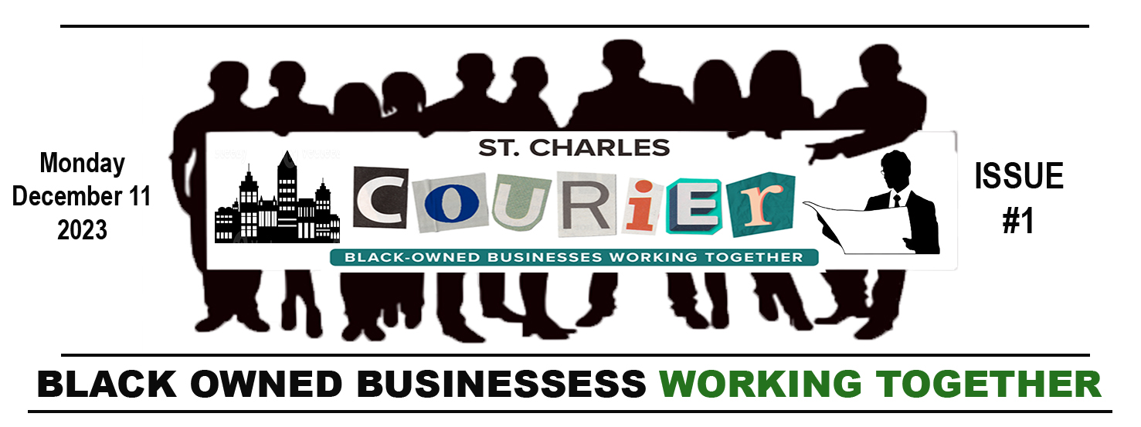

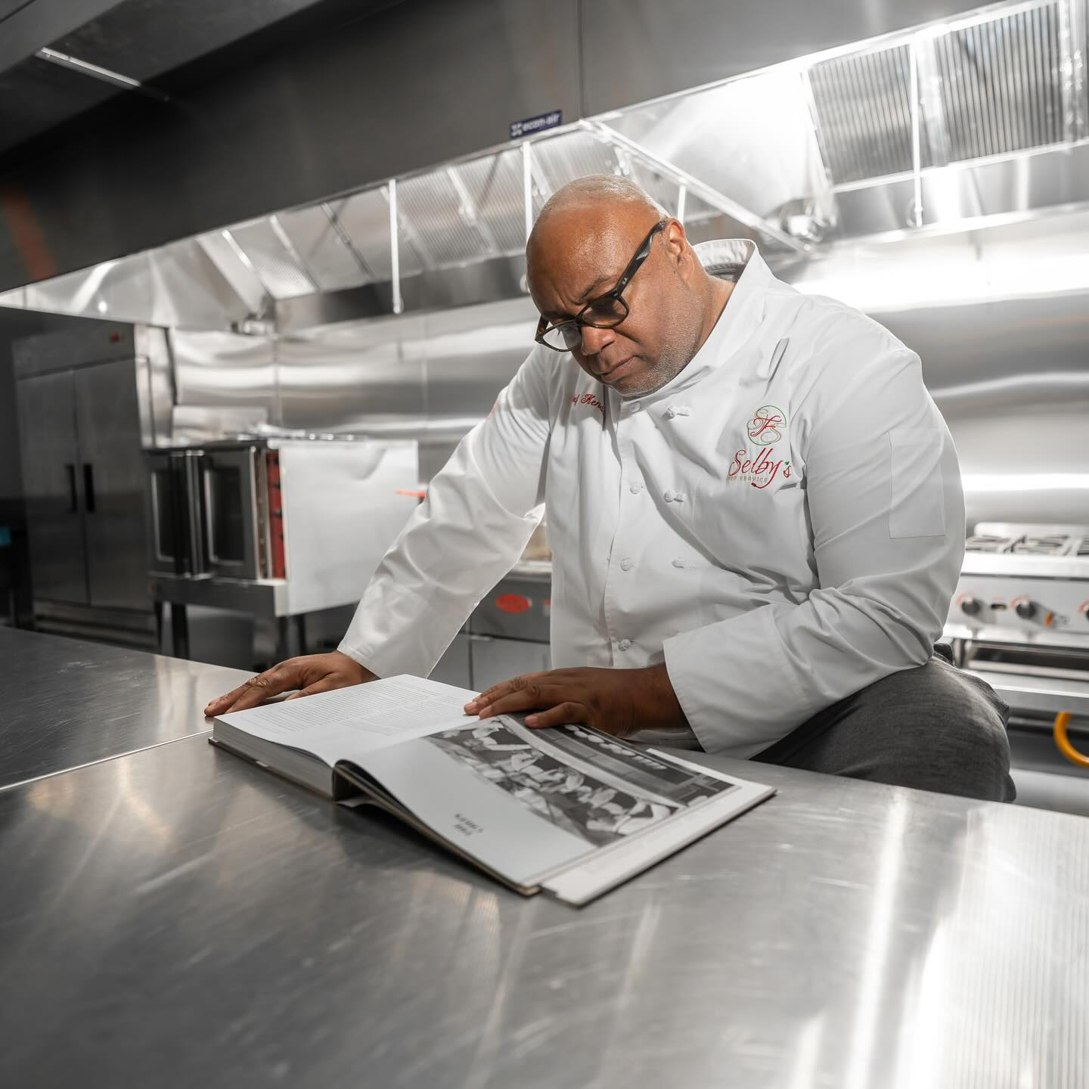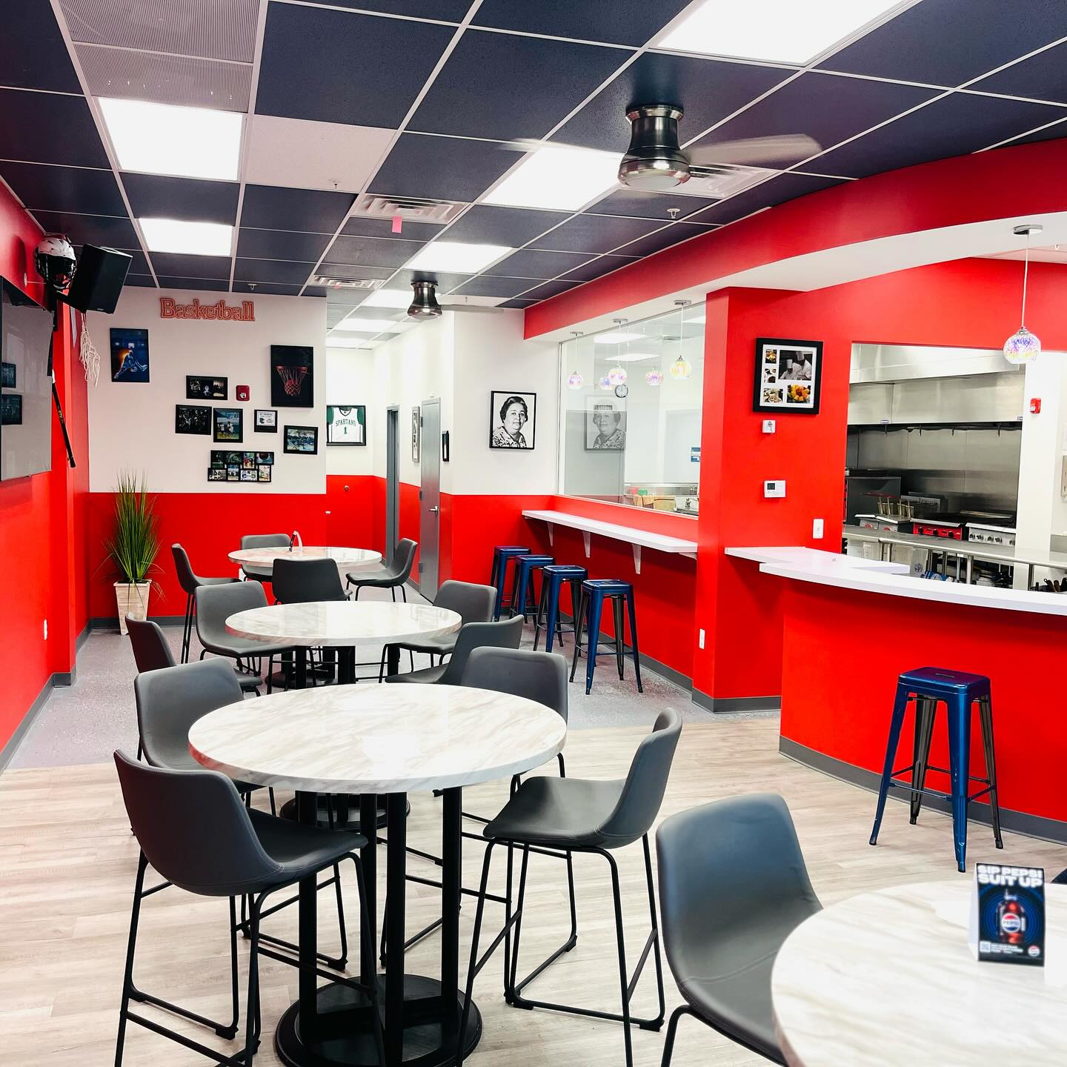

SELBY’S FOOD SERVICE “Serving The Community”

By Silvio Robinson
Chef Kendall Selby is an Internationally-Trained Chef hailing from New Jersey who resides in St. Charles County and is giving back to his community with the opening of Selby’s Food Service “Selby’s Grab and Go!”  The opening of Selby’s Food Service “Selby’s Grab and Go,” has been a long time coming but ladies and gentlemen you won’t have to wait any longer. Monday, December 11th, 2023 will mark the official opening of Selby’s Food Service, with all the bells and whistles of a Grand Opening, featuring a Ribbon Cutting Ceremony with the likes of local politicians and Who’s Who in the life of Chef Kendall Selby.  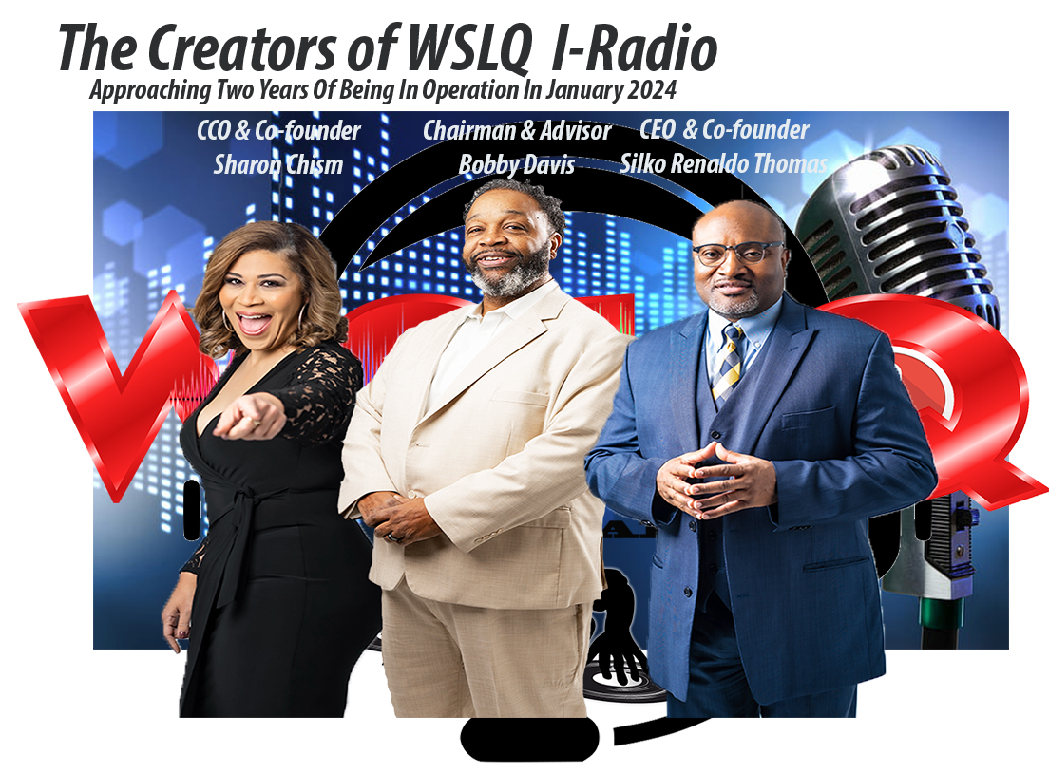WSLQ I-RADIO “The Switch Is On” New In The Local Community  By Victoria Turrentine  Before retiring from his government job of over 30 years, CEO and Operations Manager, Silko Thomas followed his passion for media. He created his own Radio Station, WSLQ I-Radio, which is a worldwide internet radio station along with his partners CCO Sharon Chism and Radio Station Chairman Bobby Davis. Together they designed the station to reach a global audience starting on day one of its operation.  The programming of WSLQ’s music is diverse which includes Jazz, Latin, R&B, Reggae, Neo-Soul, Blues, World Music, Afro Beats, Calypso and more. WSLQ’s motto is “We Are The World Community & The Switch Is On.” We wanted to be a station that could establish a direct connection with communities from South Africa, Switzerland, London, Paris, Senegal, India, Korea, Brazil, Canada, Mexico just to name a few.  WSLQ’s DNA is that of the Indie Artist. Our mission is to show love to the diversity of the Indie Artists around the World, around the Globe and just around the Corner to include  “THE WORLD ACCORDING TO SYLK” every Wednesday from 8pm to 10pm, in which she introduces a new artist that she has researched and reviewed. 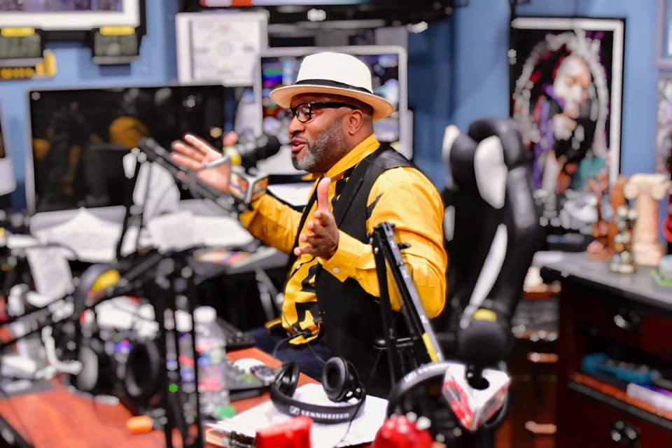  Chief Communications Officer Sharon Chism wears a number of titles within the operation of WSLQ I-Radio such as Program Director, Assistant Editor and Radio Personality just to name a few. She helms a radio program “The Weekend Windup Show” every Sunday from 2pm to 4pm. |  | Chef Selby says, “we are a casual eatery where comfort meets culinary creativity, offering a diverse menu that satisfies all appetites.” Selby will always ask the question, “Are you hungry?” then “Come and get it! It’s that simple. Don’t worry about what meals they serve because they served breakfast, lunch and dinner.  December is the perfect time for family and friends to celebrate the holidays with good food for the soul. So, if you’re hungry come and get it, they will be waiting to meet you soon. They are located at 11672 Billingsley Road, Waldorf, Maryland. They also deliver so you can reach them at 301.932.8100.  our local artists here in St. Charles County and the DMV.  WSLQ I-Radio will be celebrating its birthday during the month of January 2024 marking two years of broadcasting. In just two years WSLQ has interacted with a number of Indie Artists and well as Industry Legends such as Glen Jones, Melba Moore, Jeanne Carne, Shirley Jones, After 7, Stokley formerly of Mint Condition, ConFunkShun, Heatwave, Miki Howard, Howard Hewitt, Gerald Alston of the Manhattans, The Weather Girls, Arnell Carmichael of Raydio, Maysa, Melvin Riley from Ready For The World, Randy Hall, Frank McComb, Ladies of Skyy.  WSLQ has established relationships with folks such as WSLQ’s United Kingdom Ambassador Of Music Suzy Sue. Suzy has a weekly radio segment on the radio  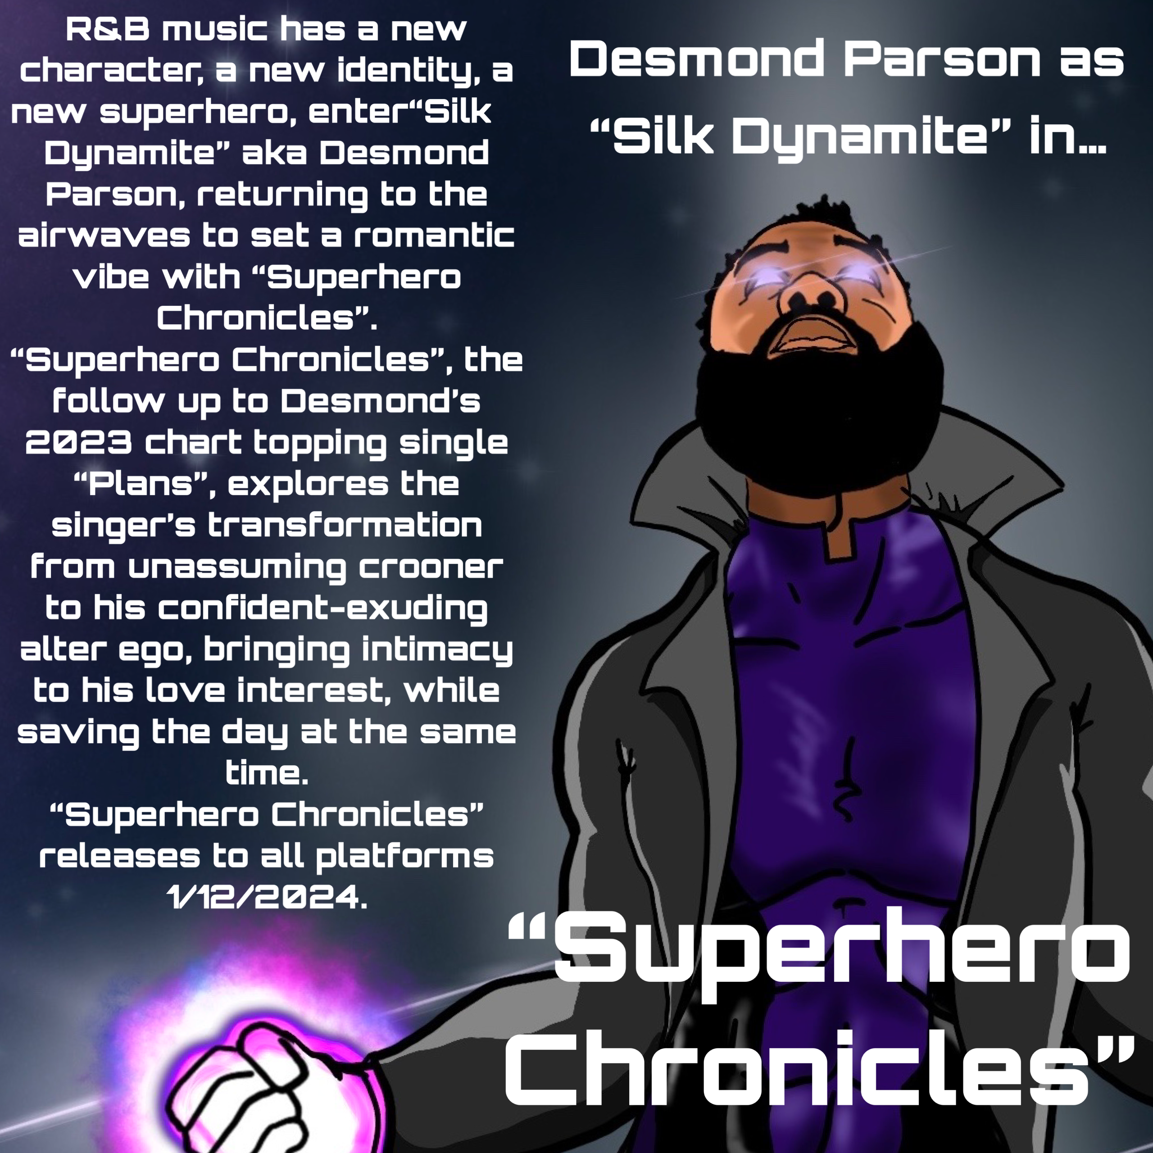  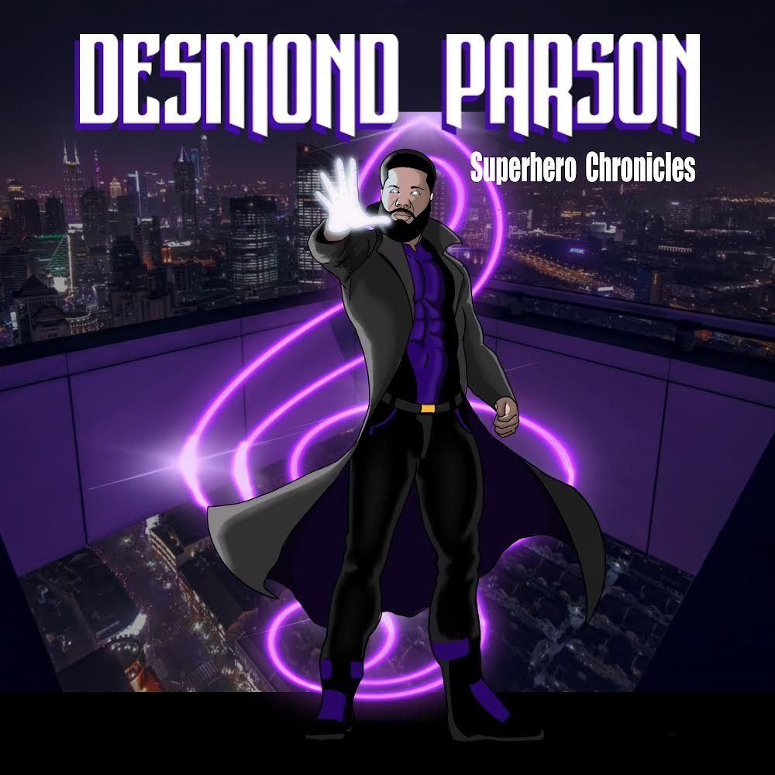
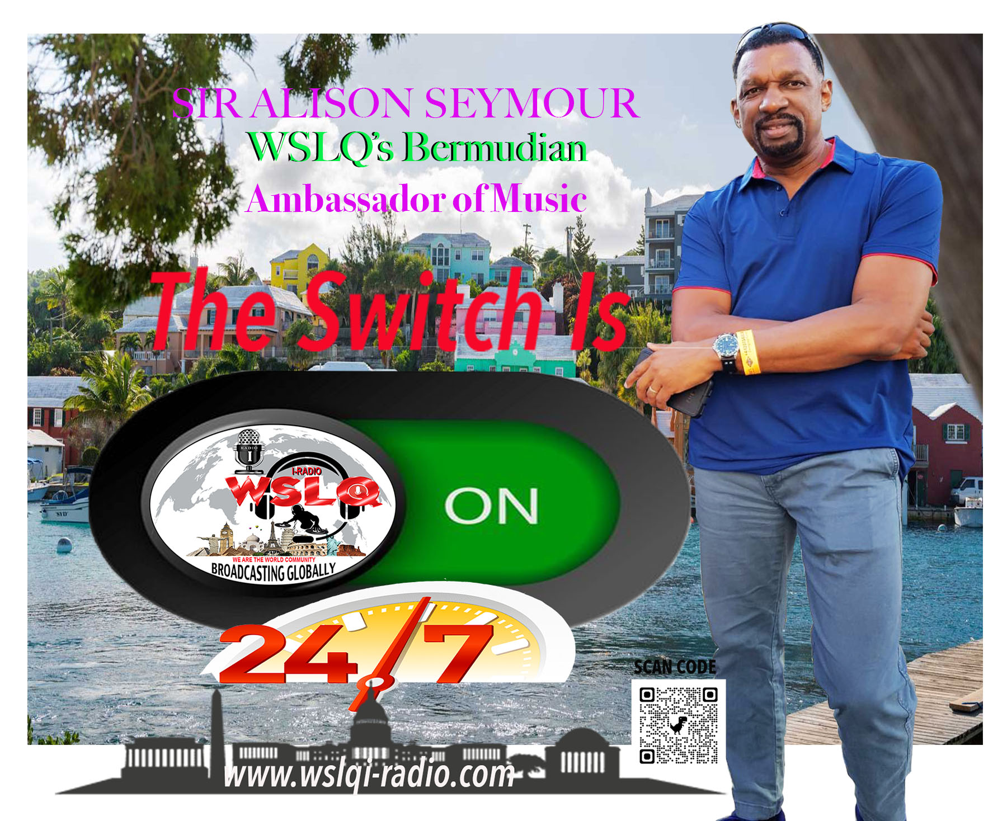
WSLQ produces a number of segments for its programming such as If The Hill Could Talk (Pittsburgh, PA), Globally Black History Moments, Blue Eye Soul, Busta Move Song Of The Week, Artist Spotlight, Indie Moment, Current News, Sophisticated Ladies, Deck Of Cards, Slow Jam Song of the Week, Intimate Concert Series, and Special Guest Co-hosting Artists.
Be sure to tune into the following shows throughout the week: Sundays THE WEEKEND WINDUP 2pm – 4pm, Rebroadcasting of both THE WORLD ACCORDING TO SYLK 5pm-7pm, and THE INDIE HOUR 7pm- 8pm, Tuesdays REBROADCAST TUESDAY every show from the previous week from 7am-2pm, Wednesdays THE WORLD ACCORDING TO SYLK 8pm-10pm, Fridays THE FORECAST SHOW 7pm-8pm, Saturdays THE INDIE HOUR 12noon-1pm and THE SATURDAY AFTERNOON DRIVE 2pm-3pm. We are WSLQI-RADIO.COM contact us at wslqiradio@aol.com.
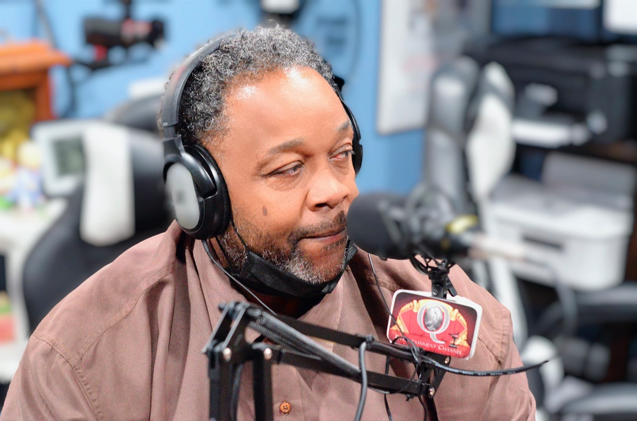 |  | They put the word "Special" in Special Events! Some of the venues utilized by BD Promotions include elegant banquet halls, such as Middleton Hall/ Grace's Event Center, large outdoor areas, such as Charles County Fair Grounds, lounges, firehouses, hotels and halls such as The Shark Bar, Fire Station One, Double Tree Hotel and Luke Hall.
BD PROMOTIONS  The Details Are What Matters Most By Sharon Chism  BD Promotions founded by Mr. Bobby Davis a local businessman. Founded in 2010 BD Promotions a black owned company located in the DMV has provided an impeccable entertainment experience in upscale venues in the DMV with top notched entertainers such as Clarett King, CL Smooth, Peter Gunz, and Parliament Funkadelic's Alumni just to.name a few.  BD Promotions promotes events all thru out the calendar year. Their events range in scale from large, medium to intimate, to include both indoor and outdoor events. Their diverse and sophisticated clientele holds itself to a high standard of excellence.  BD Promotions strives to continually provide clients with excellent entertainment experience. BD Promotions has been blessed with the return of repeat clients and it vows to maintain a high level of customer satisfaction. |  | EXCLUSIVE 360 DMV  State Of The Art Photo Booth  By Silvio Robinson  The mission of Exclusive 360 DMV is to capture your favorite moments thru a photogenic lens with a 360-degree experience. Exclusive 340 DMV was founded by The Hargraves in 2023. We too are a black owned company devoted to customer satisfaction. We service the DMV and beyond. The road is nothing new to us we will travel for weddings, special celebrations, birthday parties, corporate events and more. When you are ready to book us for your next event you can email us at Exclusive360dmv@gmail.com or call 240.416.9287. We are here and ready to make your next event unforgettable. Email us to include your name, phone number, package choice, date of event and type of event. We will response within 24 hours.
Do You Know Sharon Chism? By Thurman Hayes & Sharon Chism  Sharon Chism is Co-Founder, CCO, Program Director and Radio Host for WSLQ I-Radio since the station went live in 2022. As a native Washingtonian, she grew up listening to Donnie Simpson, Candi Shannon and Melvin Lindsay. These radio personalities not only guided her musical journey, but they also helped her to define one of her interests, radio broadcasting.  Upon entering Howard University, Sharon was a Radio and Television Broadcasting major. Although she received her degree in History, she never lost her love for broadcasting.  In 2021, when approached about building an infrastructure for a global radio station that gives Indie Artists and other talented members of her community opportunity to engage their talents, she gladly accepted the challenge.  As Program Director, Sharon works with radio host to identify and program new music, schedule interviews and events with the global Indie Artists.  As CCO, she ensures that the station’s technology infrastructure is operating optimally and employs the latest technology needed to reach our global audience and expand our generational reach.  As radio host of The Weekend Windup on Sundays from 2pm to 4pm, she entertains listeners and reminds them that the weekend is not over yet, by playing Old and |  | 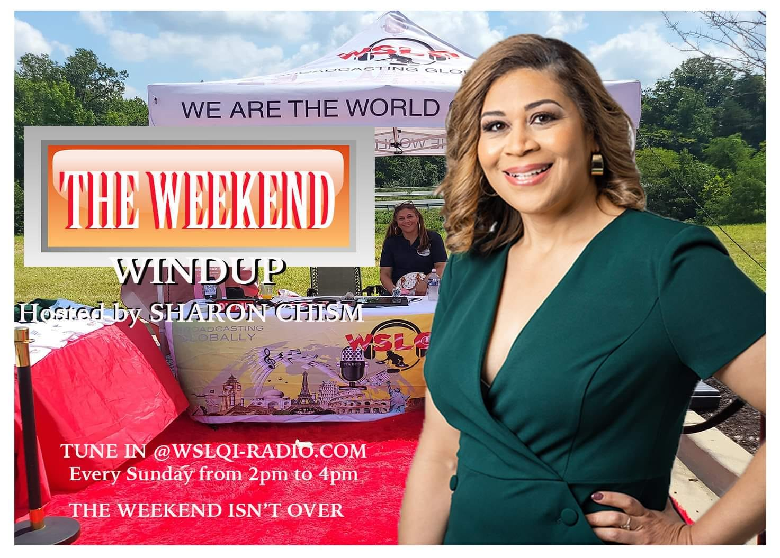  New school R&B, Hip-hop, Rap, and Jazz from independent, legendary, and current artists from around the world.  On any given Sunday at 2pm, you can hear her say, “Good Afternoon, Welcome to The Weekend Windup. This is your girl ShaSha and I am your hostess with the moistest.  CONTACT ST. CHARLES COURIER @SILKHEARTPRO@AOL.COM for your submissions for the next news entries showcasing Black Owned Businesses Working Together.

